CSC387 Lab 02 – IP Routing

## Verification Steps

1. 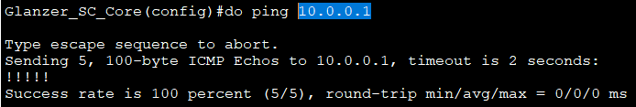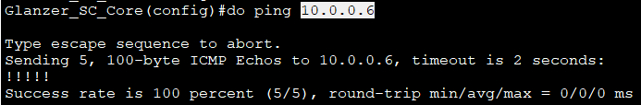SC_Core should be able to ping both the KML_Edge and BIT_Edge routers on its directly connected networks.
2. 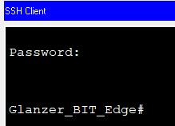You should be able to SSH into the BIT_Edge router from Laptop 2.
3. 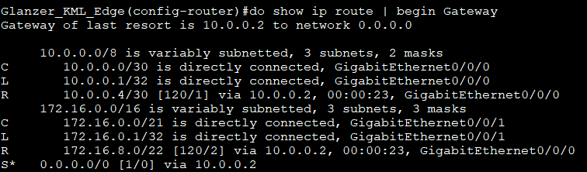From the KML_Edge router, doing a **show ip route** will display a default route (with an asterisk * by it) pointing towards 10.0.02.
4. 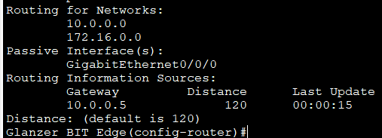On the BIT_Edge router, doing a **show ip protocols** will display some information about RIP. Look for the line that says, “Routing for Networks:” and you will see the two networks that you have advertised as well as the administrative distance below it.
5. 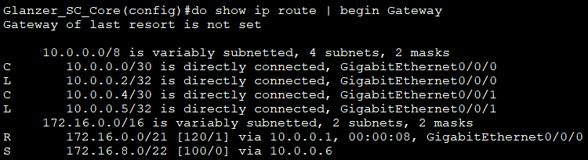On SC_Core, doing a **show ip route** will show the path to get to both laptop networks. Laptop 2’s network will come from a static route and Laptop 1’s network will come from a RIP route.
6. Laptop 1 should be able to ping Laptop 2 and vice versa. If you are using your laptops to test, you may have to temporarily disable the firewall or make a rule to allow the ICMP traffic.

